Software Requirements Specification

for

Exam Schedule Management System

**Version 1.0 approved**

**Prepared by Group 2**

**Dao Nguyen Huy Nhan - SE171010**

**Ngo Gia Huan - SE171018**

**Nguyen Tuan Loc - SE161090**

**Dao Xuan Quy - SE170242**

**NJS1706**

**November 2, 2023**

**Table of Contents**

**1. Introduction 2**

1.1 Purpose 2

1.2 Document Conventions 2

1.3 Project Scope 2

1.4 References 3

**2. Overall Description 3**

2.1 Product Perspective 3

2.2 User Classes and Characteristics 4

2.3 Operating Environment 5

2.4 Design and Implementation Constraints 5

2.5 Assumptions and Dependencies 6

**3. System Features 6**

**4. Data Requirements 16**

4.1 Logical Data Model 16

4.2 Data Dictionary 16

4.3 Reports 20

4.4 Data Acquisition, Integrity, Retention, and Disposal 20

**5. External Interface Requirements 21**

5.1 User Interfaces 21

5.2 Software Interfaces 21

5.3 Hardware Interfaces 22

5.4 Communications Interfaces 22

**6. Quality Attributes 23**

6.1 Usability 23

6.2 Performance 23

6.3 Security 24

6.4 Safety 24

**Appendix A: Analysis Models 24**

**Revision History**

| **Name** | **Date** | **Reason For Changes** | **Version** |
| --- | --- | --- | --- |
|  |  |  |  |
|  |  |  |  |

# Introduction

## Purpose

At FPT University in Ho Chi Minh City, the management of exam schedules for lecturers and students still faces many inadequacies because they still have to use notices posted in front of the exam room, and do not apply technology to manage exam schedules, causing difficulties in testing. exam management. Controlling and receiving their notifications is difficult. This causes many problems in efficiency and reliability in organizing exams. Therefore this software was born.

## Document Conventions

This document follows standard document conventions. Requirement identifiers will follow the format "BO-X" for Business Objectives, and any specific text styles or notations are consistent with industry standards.

## Project Scope

The FU Exam Management System is a modern, effective, and technologically integrated system designed to improve problems in exam scheduling and administration at FU HCM. It helps instructors, students, and university administration by automating exam scheduling, alerts, and management. The system's scope includes features for scheduling, real-time updates, and seamless access to schedules. It also aims to be easier to expand and less expensive.

# Overall Description

## Product Perspective

An examination management system is software that’s been developed to manage the entire exam process. It should be able to automate the entire exam process to save time and provide accuracy. The system covers all the activities that are related to examination management, right from receiving enrollment and examination forms, to the processing of exams, printing, distribution, and statistical reports.

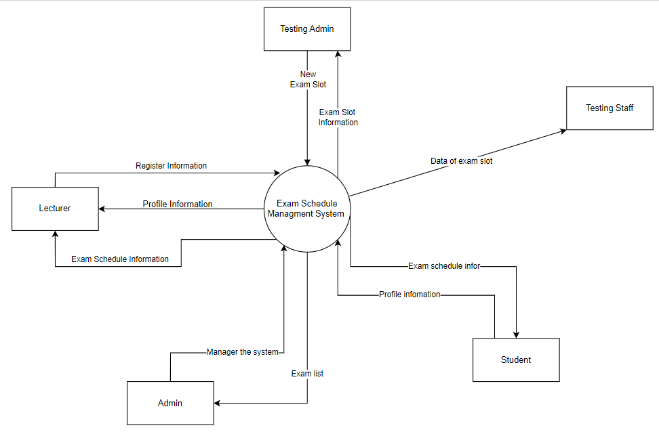

## User Classes and Characteristics

University Administrators:

* Responsibilities: Exam scheduling, organization, and management.
* Characteristics: Varying levels of technical expertise, responsible for system configuration and administration.
* Needs: Comprehensive overview of the scheduling process, access to administrative features.

Students:

* Responsibilities: Access their exam schedules, receive notifications, and resolve schedule conflicts.
* Characteristics: Limited technical knowledge, primarily use smartphones and web browsers for access.
* Needs: User-friendly interface, accessibility on smartphones and web browsers.

Lecturers:

* Responsibilities: Assign and receive notifications about invigilation schedules efficiently.
* Characteristics: Varying technical skills.
* Needs: User-friendly interface, real-time access to scheduling information.

## Operating Environment

Hardware Platform: The system should be accessible from standard personal computers and mobile devices (smartphones and tablets).

Operating Systems: The system should be compatible with major operating systems, including Windows, macOS, iOS, and Android

## Design and Implementation Constraints

CO-1: The system’s design, code, and maintenance documentation shall conform to the *Process Impact Intranet Development Standard, Version 1.3* [1]*.*

CO-2: The system shall use the current corporate standard Oracle database engine.

CO-3: All HTML code shall conform to the HTML 5.0 Standard.

CO-4: The system should be able to schedule exams within a specific time frame.

CO-5: The system should be compatible with different platforms and devices.

## Assumptions and Dependencies

AS-1: Availability of Data: The system relies on the availability of accurate student and lecturer data, which should be accessible through the university's existing databases.

AS-2: Support and Maintenance: It is considered that there will be enough funding available for system upgrades, maintenance, and support.

AS-3: Third-Party Integration: If third-party components or services are used, they should be available and compatible with the system's requirements.

AS-4: Regulatory Compliance: The system's operation should comply with relevant data protection and educational regulations.

DE-1: External Dependencies: The project may be impacted by external factors such as changes in university policies, academic calendar modifications, and third-party service disruptions.

# 

# System Features

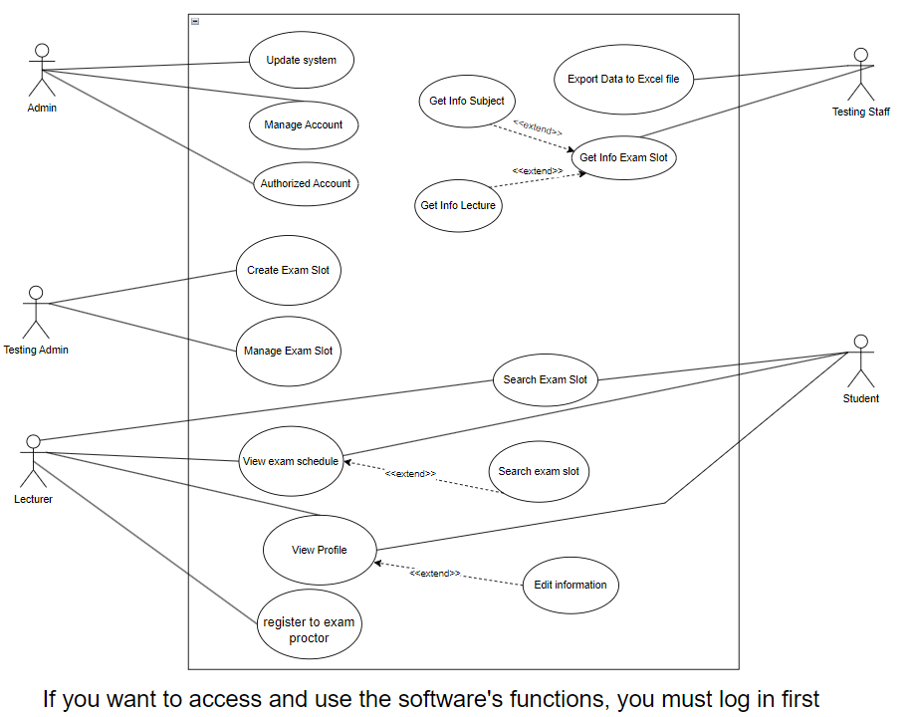

| UC ID and Name: | **UC-4 Create Exam Slot** | | |
| --- | --- | --- | --- |
| Created By: | Ngo Gia Huan | Date Created: | 28/09/2023 |
| Primary Actor: | Testing Admin | Secondary Actors: |  |
| Trigger: | Testing Admin indicates that he wants to create exam slot for each subject | | |
| Description: | This use case describes the process Testing Admin creates exam slots for subjects within an examination system. | | |
| Preconditions: | PRE-1. The Testing Admin must be authenticated and logged into the examination system. | | |
| Postconditions: | POST-1. Exam slots for the specified subjects are successfully created in the examination system.  POST-2. The system is updated with the new exam slot information. | | |
| Normal Flow: | 1. The Testing Admin navigates to the "Exam Slot Management" or equivalent section of the system. 2. The system presents a form or interface for creating a new exam slot. 3. The Testing Admin selects the subject(s) for which exam slots need to be created. 4. For each selected subject: 5. The Testing Admin enters the exam date and time. 6. The Testing Admin submits the form to create the exam slots. 7. The system validates the information and confirms the successful creation of exam slots. | | |
| Alternative Flows: | 1. If the system encounters errors during the form submission (e.g., invalid date, time conflicts), it will prompt the Testing Admin to correct the errors and resubmit. 2. If the Testing Admin cancels the operation at any point, the use case terminates without creating any exam slots. | | |
| Exceptions: | 1. If the Testing Admin's session expires or they are no longer authenticated, the system will prompt them to log in again. 2. If there are technical issues or system downtime, the use case may be interrupted, and the Testing Admin will need to retry later. | | |
| Priority: | High | | |
| Frequency of Use: | This use case is frequently used during the exam scheduling period, typically at the beginning of each academic semester or exam cycle. | | |
| Business Rules: | BR-6: Only Testing Admin can create, edit, or delete exam slots.  BR-7: The system enforces a constraint that exam slots cannot overlap in time  BR-8: The system provides a user-friendly interface with date and time pickers to facilitate the selection of exam date and time(quality)  BR-9: Based on the selected exam date and time, the system infers whether there are any scheduling conflicts with existing exam slots  BR-10: The system calculates the maximum capacity of each exam slot based on user input and predefined rules, ensuring that the limit is not exceeded which is config by admin. | | |
| Other Information: | 1. The system shall provide a date and time picker interface for the Testing Admin to select the exam date and time when creating exam slots. 2. The system should allow the Testing Admin to set a maximum capacity for each exam slot, limiting the number of students who can register for a particular exam session. | | |
| Assumptions: | The Testing Admin is knowledgeable about the exam schedule and requirements for each subject.  The examination system is functional and accessible.  Subject information is accurately maintained in the system. | | |

| UC ID and Name: | **UC-6 Export data to Excel file** | | |
| --- | --- | --- | --- |
| Created By: | DAO NGUYEN HUY NHAN | Date Created: | 28/09/2023 |
| Primary Actor: | Testing Staff | Secondary Actors: |  |
| Trigger: | Testing Staff will export Exam slot’s data to Excel file for lecture. | | |
| Description: | When the lecturer goes to watch the exam, they need a paper containing everything about the exam room they will be watching. The Testing Staff is responsible for exporting each data to an Excel file and giving it to the lecture for the exam. | | |
| Preconditions: | PRE-1. Testing Admin logged into ESMS.  PRE-2. Testing Admin access to suitable Exam slot. | | |
| Postconditions: | POST-1. Excel file content data of exam slot.  POST-2. | | |
| Normal Flow: | 1. The system will respond to exam slots available that day. 2. Testing Staff select 3. s the appropriate exam slot and presses the export button. 4. The system will access that exam slot and export all data of that into Excel file. 5. Testing Staff open Excel File and print for Lecture. | | |
| Alternative Flows: | 1. If a lecture provides incorrect or incomplete information about their Exam slot, Testing Staff should inform them of the issue and request the necessary details for export.  2. In case there are multiple Exam slots for the lecture to supervise, Testing Staff will ensure that each slot's data is correctly exported to separate Excel files or separate sections within the same Excel file to maintain clarity and organization.  3. If there are technical issues during the export process, such as system errors or formatting problems, Testing Staff should troubleshoot and resolve these issues promptly. If unable to resolve, they should report the issue to the appropriate IT support personnel. | | |
| Exceptions: | 1. If Testing Admin is unable to log into ESMS (Exception: Login Failure), they should follow the appropriate authentication or password recovery procedures and retry logging in.  2. If Testing Admin does not have access to a suitable Exam slot (Exception: Access Denied), they should seek assistance from higher-level personnel or supervisors. | | |
| Priority: | High | | |
| Frequency of Use: | This process is typically performed during the examination period and can be frequent, depending on the number of exams scheduled. | | |
| Business Rules: | BR: The process of exporting the data should be efficient to ensure timely delivery to the lecturer.  BR: Security measures should be in place to protect sensitive exam-related data.  BR: Testing Staff must compile and format the data accurately in the Excel file to ensure it is easily readable by the lecturer.  BR: Testing Staff can print the exported data in multiple sheets. | | |
| Other Information: | This process is critical for ensuring that lecturers have the necessary information to supervise exams effectively, and it contributes to the smooth conduct of examinations within the educational institution. | | |
| Assumptions: | 1. The ESMS (Exam Schedule Management System) is a reliable and functional platform that Testing Admin can access without major technical issues.  2. Lecturers are responsible for providing accurate and complete information about their Exam slots to Testing Staff for export. | | |

| UC ID and Name: | **UC-9 View Exam Schedule** | | |
| --- | --- | --- | --- |
| Created By: | Dao Xuan Quy | Date Created: | 9/28/23 |
| Primary Actor: | Student and Lecturer | Secondary Actors: | Exam Schedule |
| Trigger: | A Student or a Teacher indicates that he/she wants to view the exam schedule. | | |
| Description: | This feature is used to view the exam schedule for lecturers and students. | | |
| Preconditions: | PRE-1: Students/Lecturers are logged into ESMS.  PRE-2. Students/Lecturers are registered by using their education login. | | |
| Postconditions: | POST-1. All subjects of the exam are displayed in the "View Exam Schedule" section of the system.  POST-2. All information related to exam subjects such as exam date, exam room, exam time, exam retake time, and exam format of each subject are shown on schedule. | | |
| Normal Flow: | **9.0 View Exam Schedule**  1. Student/Lecturer finds the "View Exam Schedule" section and chooses.  2. ESMS displays exam timetable of each subject.  3. Student/Lecturer views specific information about each exam subject for the upcoming exam. | | |
| Alternative Flows: | None | | |
| Priority: | Medium | | |
| Frequency of Use: | Approximately 500 users, average of one usage per day. | | |
| Business Rules: | BR-11: All information about exam schedule is required to be announced within 7 days before the exam begins.  BR-14: Students should be able to filter or search for details about their exam based on subject name, exam date or other relevant criteria. | | |
| Other Information: | 1. Expect higher frequency of executing this use case when there is a large number of users accessing the system.  2. All information displayed on the exam schedule will be deleted by the Testing Admin after the exam is over. | | |

| UC ID and Name: | **UC-12 Register to exam proctor** | | |
| --- | --- | --- | --- |
| Created By: | Nguyen Tuan Loc | Date Created: | 28/09/2023 |
| Primary Actor: | Lecturer | Secondary Actors: | Exam slot |
| Trigger: | lecturer wants to become a proctor for the current semester's exam | | |
| Description: | To become a proctor for the exam, you need to register and be approved, then you will be on the proctor list and work as a proctor for sessions that follow the exact exam schedule. | | |
| Preconditions: | PRE-1. The lecturer must be authenticated and logged into the examination system.  PRE-3 with the number of supervisor positions on the list being 4 times smaller | | |
| Postconditions: | POS-1 After checking to see if the number of missed exams recorded in the list of proctors for the current term will output "Success".  POS-2 The system will increase the number of times being a supervisor in the list by 1 more. | | |
| Normal Flow: | 12.0 The first Register to exam proctor  1. when you are eligible to register and this is the first time the lecturer has registered to be a supervisor.  2. CES You are currently eligible to register as a supervisor  3. Instructors will see a list of exam subjects for this semester  4.CES The name of the newly registered lecturer will be placed on the system's waiting list  5. Waiting lists will be processed and arranged after a full list of testing rooms is available  6. Instructors will wait until the public announcement date to receive the list of tests that they personally supervise | | |
| Alternative Flows: | 12.1 Invalid Proctor Information   1. The system detects invalid information and displays error messages, prompting the proctor to correct the errors before proceeding with registration.   12.2 Proctor Withdraws Registration   1. The proctor accesses their registration details, selects the exam they want to withdraw from, and confirms the withdrawal. 2. The system updates the registration status accordingly. Returns to screen flow. | | |
| Exceptions: | 1.0.E1. The request date is posted too close to the exam date  1.Notify the instructor that the deadline to register as a supervisor has passed  2. The system cancels the registration request  1.1.E1. There are enough supervisors that the school needs  1. The lecturer's request was approved but the number of supervisors was sufficient  2.The system will cancel the request  1.2.E1 Lecturers have reached the maximum number of exam guards  1.EOS notifies lecturers whose number of exam shifts has reached the maximum  2. Exit the registration screen | | |
| Priority: | Medium | | |
| Frequency of Use: | Approximately 200 users, average of one usage per day. Peak usage load for this use case is between 6:00 P.M. and 11:00 P.M local time. | | |
| Business Rules: | BR-1:Do not arbitrarily exchange exam schedules with other instructors without the consent of the exam schedule manager.  BR-2: The number of registrations for the exam guard position is less than 5 slot  BR-2: Lecturer registration is required at least 7 days before the exam and can Cancel registration 24 hours before the test takes place.  BR-3: Instructors must confirm and adhere to the assigned live schedule after they register.  BR-4: Instructors must report any problems that occur during the proctoring process, including rule violations by students. | | |
| Other Information: | 1. After registering, you have confirmed and agreed to the conditions of a proctor.  2. If you want to be absent, you must send an email to ask for permission 24 hours before the exam takes place.  3.can view all exam subjects in the current exam | | |
| Assumptions: | Suppose the lecturer is absent arbitrarily without notifying the house 24 hours in advance. (Lecturers will be handled according to school regulations) | | |

# Data Requirements

## Logical Data Model

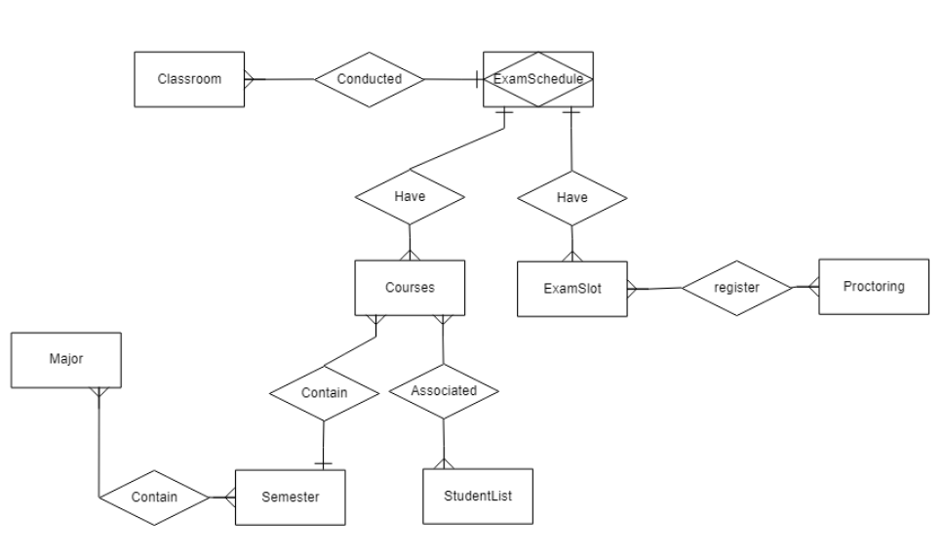

## Data Dictionary

| **Data Element** | **Description** | **Composition or Data Type** | **Length** | **Values** |
| --- | --- | --- | --- | --- |
| ExamSchedule | View the exam schedule | ExamScheduleID  + CourseID  + ExamSlotID  + ClassroomID  + Date  + StartTime  + EndTime |  |  |
| ExamScheduleID | Identify ID of exam schedule | Integer |  | Integer |
| CourseID | Course exam code | Integer |  | Integer |
| ExamSlotID | Code of Slot() that takes place the test | Integer |  | Integer |
| ClassroomID | room code where the test is taking place | Integer |  | Integer |
| Date | the date of the exam | Date | (e.g., MM/DD/YYYY) | MM/DD/YYYY |
| StartTime | Time start for exam | Time | (e.g., HH:MM AM/PM) | HH:MM AM/PM |
| EndTime | Time end for exam | Time | (e.g., HH:MM AM/PM) | HH:MM AM/PM |

| **Data Element** | **Description** | **Composition or Data Type** | **Length** | **Values** |
| --- | --- | --- | --- | --- |
| CourseID | Identify ID of each course in database | Integer | 5 | Integer |
| CourseName | Identify Name of each course in database | String |  | Char |
| SemesterID | Identify ID of each semester in database | Integer | 5 | Integer |
| StudentListID | Identify ID of each student in a student catalog in database | Integer | 5 | Integer |

| **Data Element** | **Description** | **Composition or Data Type** | **Length** | **Values** |
| --- | --- | --- | --- | --- |
| ExamSlot | Exam Slot data | Exam Slot ID Protoring ID SlotName Date StartTime EndTime |  |  |
| ExamSlotID | Define the ID of each ExamSlot | Integer | 5 | Integer |
| ProctoringID | An ID of each Proctoring join to the ExamSlot | Integer | 5 | Integer |
| SlotName | Name of slot | String |  |  |
| Date | Define Date of ExamSlot | Date |  | MM/DD/YYYY |
| StartTime | Define start time of exam slot | Time |  | HH:MM AM/PM |
| EndTime | Define end time of exam slot | Time |  | HH:MM AM/PM |

| **Data Element** | **Description** | **Composition or Data Type** | **Length** | **Values** |
| --- | --- | --- | --- | --- |
| ID | Exam Slot Identifier | Integer |  | Unique numerical identifier |
| examBatchID | Exam Batch Identifier | Integer |  | Unique numerical identifier |
| startTime | Start Time of Exam | Date and Time |  | Date and time in a specific format |
| endTime | Start Time of Exam | Date and Time |  | Date and time in a specific format |
| quantity | Quantity of Examiner who can register this slot | Integer |  | Positive whole number |
| status | Exam Slot Status | Boolean |  | Option “true” or “false” |

## Reports

## Data Acquisition, Integrity, Retention, and Disposal

DI-1: ESMS will store exam schedules of previous semesters

DI-2: ESMS will store user information

# External Interface Requirements

## User Interfaces

UI-1: The Exam Schedule Management System user interface shall adhere to the university's official User Interface Design Guidelines, as specified in the "FU HCM User Interface Standards" document.

UI-2: The system shall provide an intuitive and user-friendly interface for instructors, students, and university administrators to access and manage exam schedules.

UI-3: The user interface shall include interactive features for scheduling, editing, and viewing exam schedules, ensuring ease of use and accessibility for all user roles.

UI-4: The system shall provide a comprehensive search and filter functionality for users to quickly locate and access relevant exam schedules.

## Software Interfaces

SI-1: Student Information System

SI-1.1: The Exam Schedule Management System shall integrate with the university's Student Information System to retrieve student enrollment data for scheduling purposes.

SI-1.2: The system shall automatically update exam schedules based on student enrollment changes recorded in the Student Information System.

SI-2: Faculty and Staff Directory

SI-2.1: The system shall interface with the university's Faculty and Staff Directory to access instructor information for scheduling exams.

SI-2.2: It shall provide a mechanism for instructors to view and confirm their exam schedules through this interface.

SI-3: Email Notification System

SI-3.1: The Exam Schedule Management System shall integrate with the university's email notification system to send automated notifications and alerts to students and instructors regarding exam schedules, changes, and updates.

SI-4: Mobile Application

SI-4.1: The system shall provide a mobile application interface, allowing students and instructors to access their exam schedules on mobile devices.

## Hardware Interfaces

HI-1: No specific hardware interfaces are identified for the Exam Schedule Management System, as it primarily operates as a software application accessible through web browsers and mobile devices.

## Communications Interfaces

CI-1: The system shall support email notifications to inform users of any changes in exam schedules or important announcements related to exams.

CI-2: It shall provide real-time notifications through the mobile application to keep users updated on any last-minute changes or exam-related news.

CI-3: The system shall allow for data import/export interfaces to exchange exam schedule data with other university systems, such as the registration system or academic departments.

CI-4: In the event of scheduled maintenance or system downtime, the system shall notify users through email and the mobile application to minimize disruption.

# Quality Attributes

## Usability

USE-1: The Exam Schedule Management system shall allow students to easily view their upcoming exams and related details, including date, time, location, and any special instructions, with a single interaction.

USE-2: 90% of users, including students and administrators, shall be able to schedule or reschedule exams without errors on their first attempt.

## Performance

PER-1: The system shall accommodate a total of 500 users and a maximum of 150 concurrent users during the peak exam scheduling period, which typically occurs during the registration period, with an estimated average session duration of 10 minutes.

PER-2: 95% of web pages generated by the Exam Schedule Management system shall load completely within 3 seconds from the time the user requests the page over a 10Mbps or faster internet connection.

PER-3: The system shall generate and display exam schedules for students within an average of 5 seconds and a maximum of 8 seconds after they submit their preferences.

## Security

SEC-1: All data related to exam schedules, student information, and faculty data shall be stored securely and encrypted in compliance with relevant data protection regulations.

SEC-2: Users, including students and faculty, shall be required to log in to the system to access or modify exam schedules.

SEC-3: Only authorized administrators and faculty members shall have access to the exam scheduling and modification functionalities.

SEC-4: The system shall ensure that students can only view or modify their own exam schedules.

## Safety

SAF-1: The system shall provide a warning to students when scheduling exams, highlighting any potential conflicts or overlaps with their existing schedules to prevent academic disruptions.

SAF-2: The system shall allow for the rescheduling of exams in cases of emergencies or unexpected circumstances, ensuring flexibility while adhering to academic policies.

# Appendix A: Analysis Models

Class Diagram

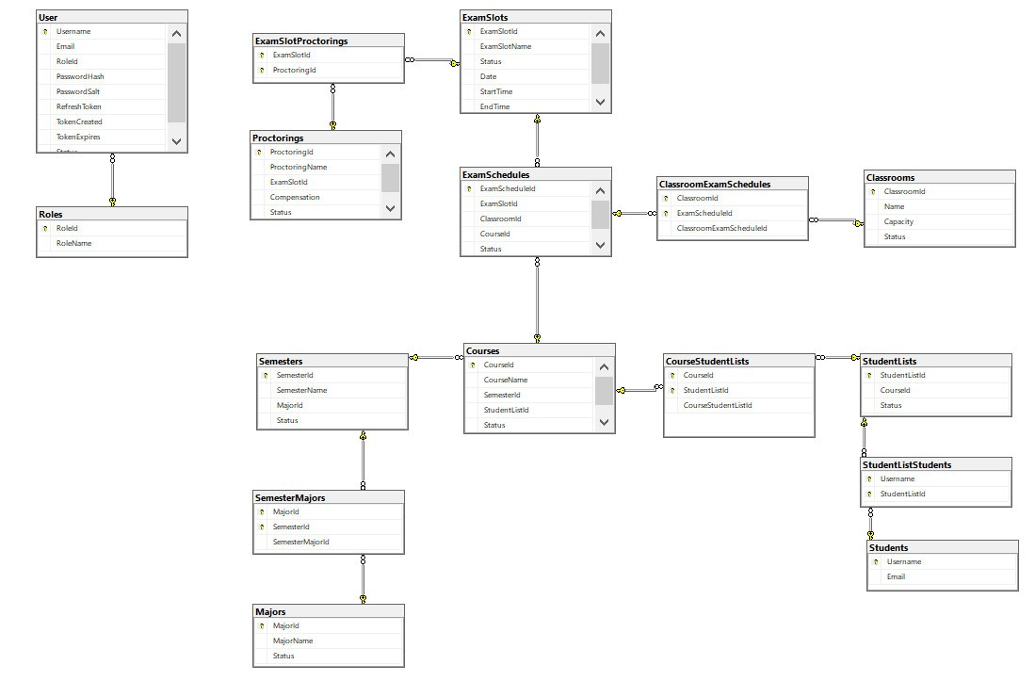

Sequence diagrams:  
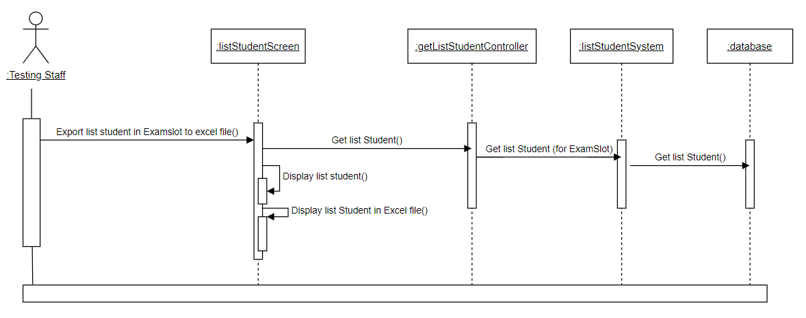

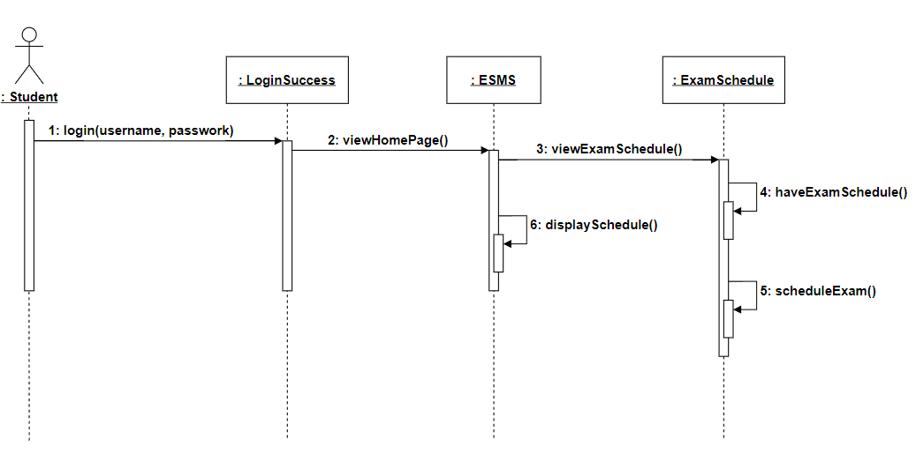

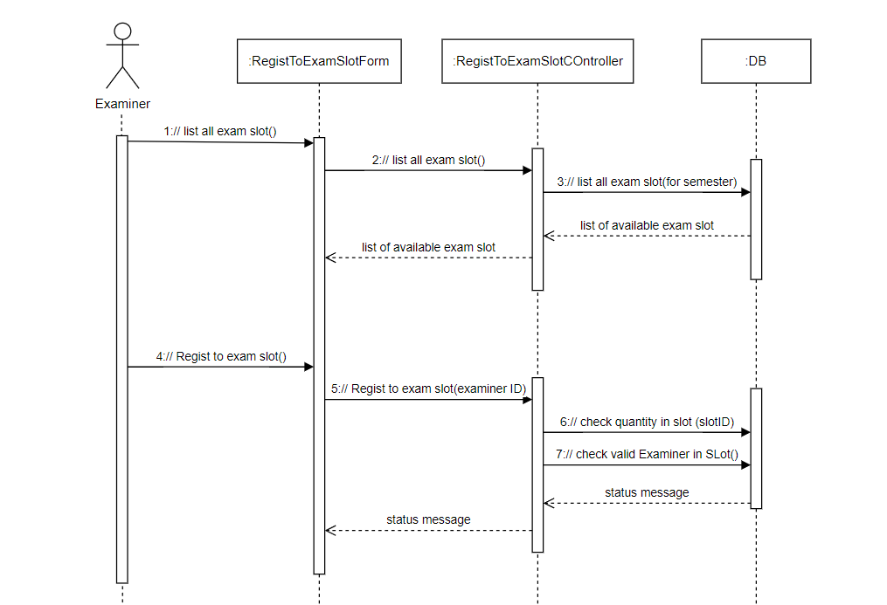

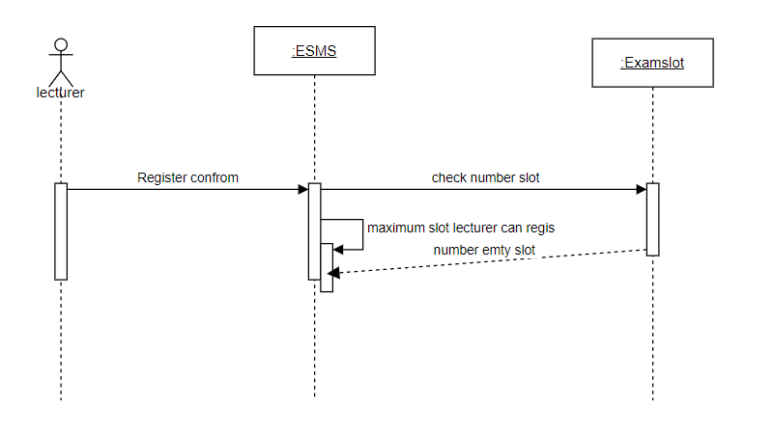

Swimlane Diagram: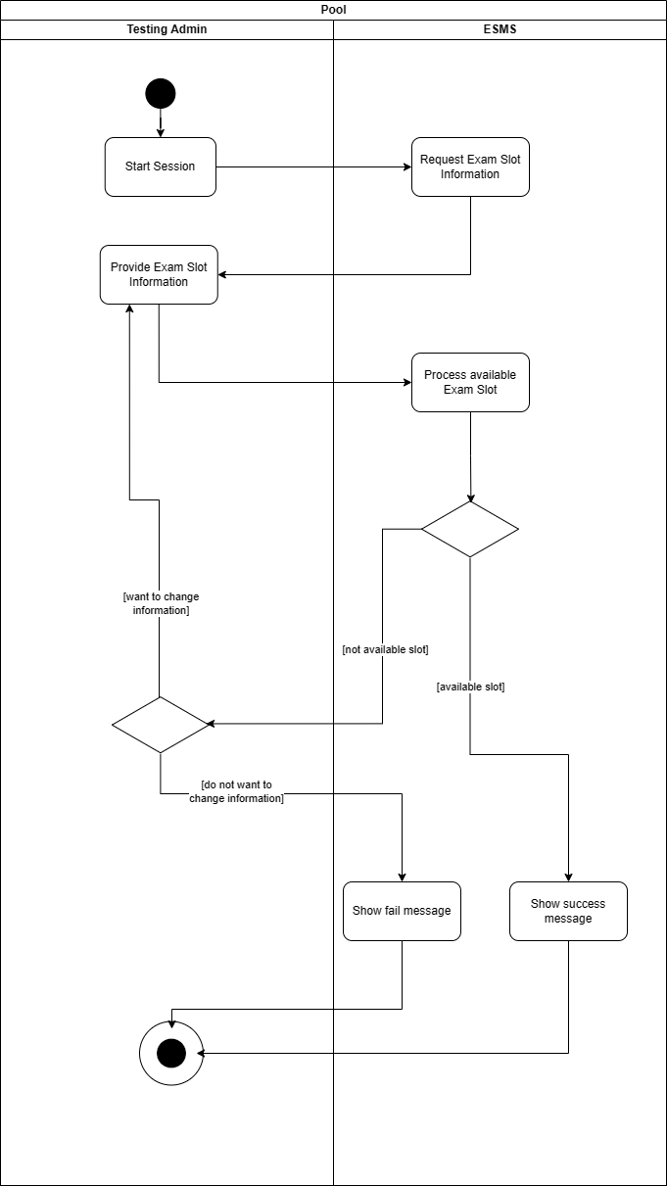

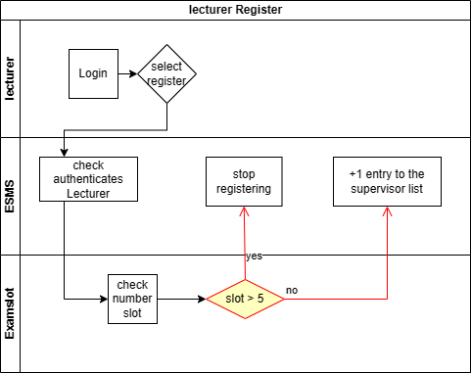

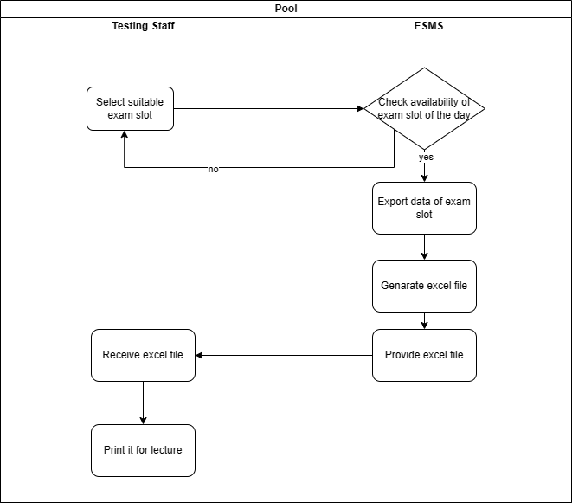

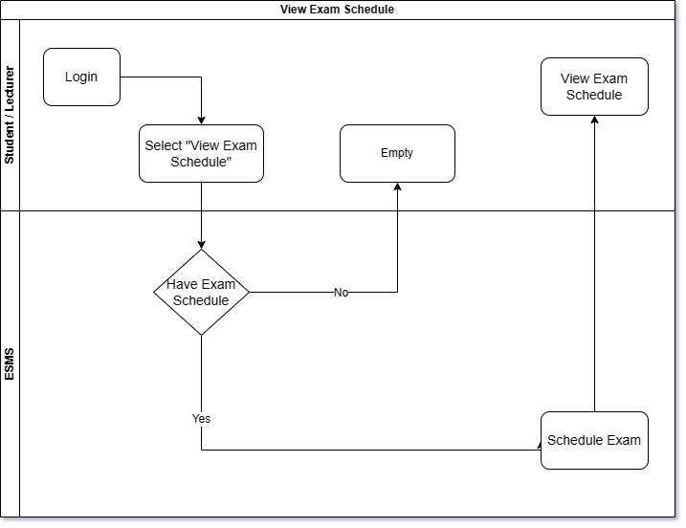

State diagram:

Testing Staff:  
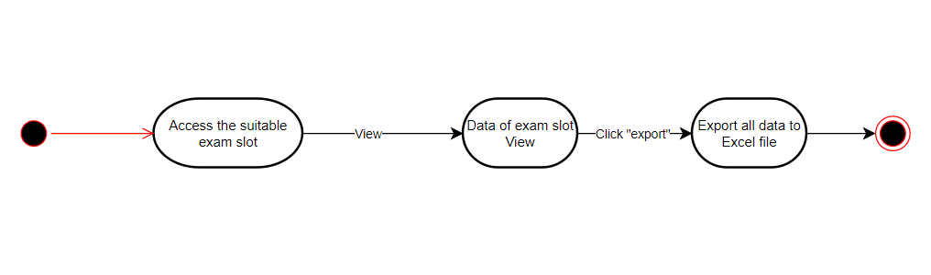

Register to ExamSlot:  
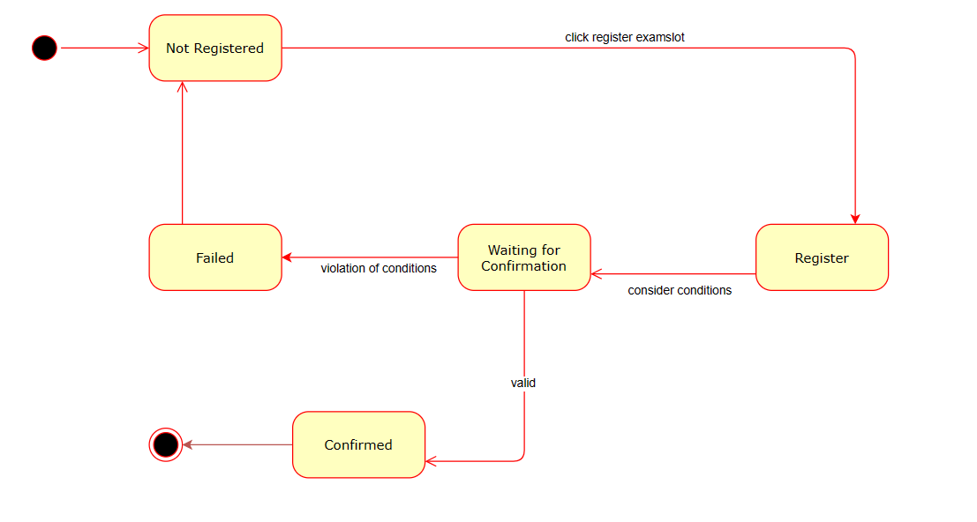

View Exam Schedule

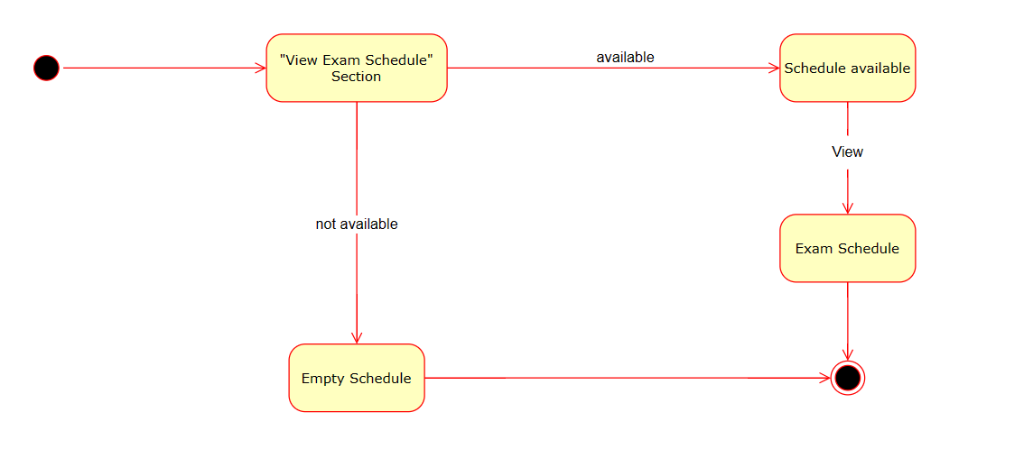

Create Exam slot:  
